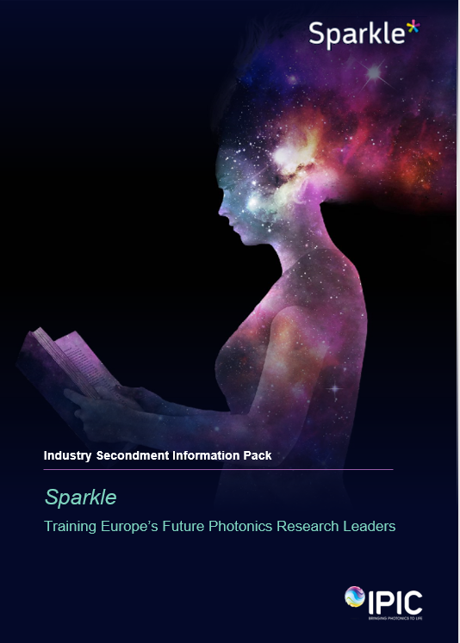

Executive Summary

Welcome to Sparkle, an innovative intersectoral training, career development and mobility training programme co-funded by the Marie Skłodowska-Curie Actions programme (EU) and Science Foundation Ireland (SFI). Sparkle is hosted by the Irish Photonics Integration Centre (IPIC), Ireland’s centre of excellence for research, innovation and training in photonics.
Sparkle has one Open Call that runs continuously from December 2019 to the end of September 2022. In this period there are regular application cut-off dates. At these Cut-Off dates, received applications in the period since the previous Cut-Off date will be reviewed

Sparkle Programme Project Proposal Details ( Candidate to complete)
Project Abstract

Subject Area
Proposed work to be carried out with Industry Partner

Candidate CV | Please attach CV file to this secondment request and share with david.mcgovern@tyndall.ie

1. About Sparkle

1.1 Background
Photonics impacts our everyday lives, from the screens that drive our mobile phones, to the fibre optic based communications network that underpins the modern internet, to light based diagnostics systems that identify diseases. It also represents an enormous worldwide sector that is growing twice as fast as the global GDP and expected to reach €704 billion in 2023. Europe is at the heart of this industry with a market that has grown by over 62% over the last 10 years, investing about €10 billion per year in innovation through its 5,000 photonics companies that directly employ over 300,000 with a global market share of 15.5%, second only to China.
The story doesn’t stop there, the industry is highly dynamic with a large number of emerging disruptive technologies and market opportunities, for example AR/VR that needs higher resolution and energy efficient displays, autonomous vehicles that require photonics sensors to ‘see’, guided surgical instruments that will utilise light to identify cancerous versus non-cancerous tissue, but to mention a few. The future is exciting, but investment is needed to enable Ireland and Europe to continue to compete on the global landscape, including the training of our future photonics research leaders with innovative independent thinking to drive leading edge research, and translational skills to turn scientific breakthroughs into technology and products that meet market needs across multiple sectors.
The Irish Photonics Integration Centre (IPIC) is emerging as one of Europe’s top research centres in photonics integration, incorporating the expertise of 17 Principal Investigators (PIs) covering topics from photonics theory through to full system development, i.e. the full technology development cycle where the underpinning sciences are explored in parallel to the development and fabrication of novel prototype devices and systems. Today IPIC comprises over 200 photonics researchers with access to world-class equipment infrastructures, including extensive optoelectronic device fabrication facilities.
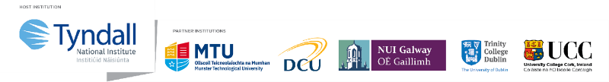
IPIC is a dispersed centre, headquartered at Tyndall National Institute, University College Cork (UCC), with academic partners including Ireland’s leading universities, Trinity College Dublin, Dublin City University, National University of Ireland Galway and Munster Technological University (Figure 1.1).
Figure 1.1 Sparkle Academic Partners
Collectively, the team publishes over 100 publications per year, with 40% in the top 10% journals as measured by SciVal (Elsevier), 60% with international collaborators and over 25% include two or more IPIC PIs demonstrating the interdisciplinary and integrated nature of the research.
Our Principal Investigators are also active research leaders in European funding programmes and have to date secured over €24M in the highly-competitive H2020 programme. This research excellence, in combination with the capability to fabricate functioning prototypes addresses the historic gap between academia and industry (typically between TRLs 3 and 5), making us an attractive partner for industry. As a result, we have in recent years expanded our industrial collaborations to more than 30 companies who provide over €3.4M per year, representing global technology leaders and rapidly growing SMEs across numerous sectors, including telecommunications, data storage, AR/VR, semiconductor, medical devices and life sciences. Training is also one of our core roles and over the last 5 years we have trained over 100 PhDs and Postdocs, with 64% taking positions in industry as their first destination. Well above international levels, and reflecting the relevance and quality of the training programmes, and close industry ties.

1.2 Equality, Diversity & Inclusion
Equality, Diversity & Inclusion (EDI) is a core principle of Sparkle and is integrated into all elements of the programme, including a transparent, fair, objective and gender-balanced evaluation and selection process. We encourage applications from all members of the photonics research community, including those from traditionally underrepresented groups, and endeavour to create a bespoke training plan for each applicant to help you achieve your own career goals and aspirations.

1.3 Programme Objectives
Sparkle is an intersectoral training, career development and mobility fellowship programme that seeks to develop Europe’s future industrial and academic research leaders. These leaders with combined skills in scientific excellence, product development and manufacturing, will be equipped to compete at the highest level and will ensure that Ireland and Europe remain at the forefront in photonics technology and industrial activity.
The programme offers 27 x two-year fellowships, with each fellow having a training plan tailored to the career path they wish to pursue following their fellowship. For fellows wishing to pursue an academic career, their training includes the identification and submission to funding opportunities to enable them build their own independent research programme upon completion of the fellowship. For fellows focussed on a career in industry, their training has greater focus on translational skills, such as fabrication and commercialisation, and they are introduced to our wide network of industry partners.
Irrespective of the direction fellows might pursue, the demand for experienced photonics researchers with the capability to be global leaders is very clear from the immensely supportive response of our industry partners to participating in the Sparkle programme. With many expressing a desire to host a fellow for their 6-month industry secondment for the programme. These companies are driving scientific development and advancement to manufacturing of new challenging and disruptive technologies across multiple sectors.
The fellow’s industry secondment is key aspect of the programme which lend to them completing their research, developing a new industrially focused skillset and broadening their network of peers. The duration of the secondment is 3-6 months and can be in one block or periodic throughout the 2 year secondment.

Programme Aims For Fellows:
- An advanced training programme in a cutting-edge research environment to train future world leaders in the field of photonics, highly employable both in academia and industry.
- An expanded set of translational skills, including prototype development and fabrication, manufacturing, problem solving, commercialisation, communication and dissemination, leadership, grantsmanship, financial management, planning and time management.
- Enhanced innovative and entrepreneurial awareness skills through training on subjects such as market awareness, Intellectual Property, licensing, technology transfer, entrepreneurship and industry engagement.
- A career-oriented 6-month industry placement with either a global leader or rapidly growing SME.
- Integration into a network of Europe’s academic and industrial leaders that will boost future career opportunities across many disciplines and sectors.
- Participation in IPIC’s comprehensive and diverse Education and Public Engagement (EPE) programme, to develop and apply dissemination skills with different audiences from school students to the general public.
- Participation in a transparent, fair, objective and gender-balanced evaluation and selection process.

Through the delivery of Sparkle we aim to:
- Strengthen and raise the excellence and impact of Ireland and Europe’s photonics research and manufacturing activities through the transition of leading edge science into market leading products.
- Address the expanding skills shortage in the field of photonics, specifically at experienced researcher level.
- Support photonics based SMEs by providing them with highly skilled trainees to support their business growth ambitions.
- Expand Ireland and Europe's research and innovation capacity and outputs, ensuring that they remain among the leading global destinations for attracting high skilled researchers to both expand their skills and also progress to fulfilling and impactful careers.

1.4 Research Areas
Independent thinking to complete leading edge research and develop solutions to solve societal challenges is a core skill for internationally leading scientists, and therefore to ensure that fellows develop this skill, each will complete a clearly defined Research Project with one of the IPIC Principal Investigators (PIs). The Research Project Plan is developed during the preparation of the application and ideally spans more than one of our research disciplines to help fellows develop their ability to work across multiple disciplines.
As with all MSCA programmes, mobility is an integral part of Sparkle, including mobility in the Research Area that a fellow pursues. However; Research Projects must align with IPIC’s core scientific research programme focussed on the development of game-changing optoelectronic integration technologies, which will also help fellows leverage the benefits of the wider research programme and to explore synergies (Figure 1.2). The research programme utilises our deep domain expertise in key underpinning disciplines, namely: theory and growth of III-V and III-Nitride materials, optoelectronic device design and fabrication, high speed microelectronics, photonic integration and packaging, biophotonics and communications systems. It is structured into four inter-disciplinary Research Themes that meet monthly to discuss the research programme and fellows will be invited to participate in these meetings:
- Monolithic and Heterogeneous Integration: ‘Printed photonics on anything’ explores new ways to combine photonics and electronics on multiple substrates with unprecedented simplicity and cost-effectiveness using transfer printing.
- Packaging and Hybrid Integration: ‘Breaking the packaging cost barrier’ develops optical and electrical wafer scale assembly and packaging processes and low cost cooling technologies.
- Communications: ‘Coherent everywhere: migration of coherent communications to the network edge’ is addressing the question, can we build a coherent transceiver for €10 and, if so, how will it transform metro-scale access network design?
- Biomedical: ‘World’s smallest integrated imaging system for guided surgery’ is developing new innovations in micro-scale cameras and surgical platform integration technologies, multi-spectral diagnostic imaging and in-body optical powering and data transmission to address this need and deliver a number of world firsts.

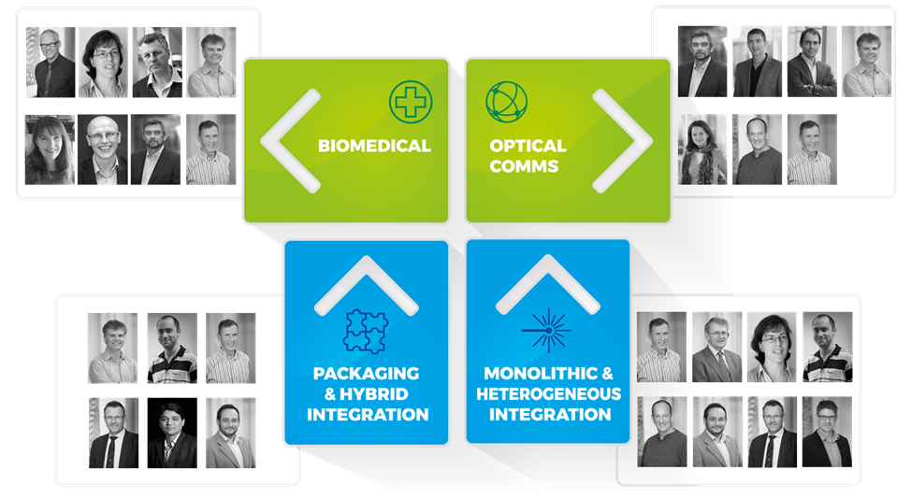
Figure 1.2 Research Themes and their participating Principle Investigators
Within the context of the Research Themes, applicants can choose the Research area and Principal Investigator to develop a research project of common interest. Further details on the Research Areas and the PIs are available at www.ipic.ie.

1.5 Industry Secondment
After selecting a suitable Principal Investigator to develop a project proposal with the Sparkle fellow needs to select an Industry Partner to complete the secondment aspect of their project with. The secondment can be up to 6 months in duration.
To be eligible to host a fellow as an industry partner a company must agree to the following terms:
- Host the fellow for a period of up to 6 months. [Continuously or periodically over the 2-year fellowship]

- Provide an industry supervisor for the fellow throughout their 2-year fellowship, to support them in the implementation of their research.

- Provide overheads for the fellow when working at the host company
  - The Sparkle grant award contributes financially to cover the costs of the fellow throughout the programme and for the duration of the programme the fellow will remain an employee of their host RPO but for the duration of the industry secondment the host company will be asked to cover the cost of the overheads for the fellow

- Provide the fellow with the necessary equipment and safe working environment to carry out their research

- Provide a supportive working environment to the fellow and enable them to grow and develop their transferrable skillset in an industry environment.
  - All training provided will be captured and recorded as benefit in kind contributions
  - Desirable training will be detailed in the fellow’s individual Personal Career Development, created on appointment to the programme.

A letter of commitment of support for the fellow is needed by the host secondment partner for their completed application to the programme, an example template of such a letter needed is given in Appendix 1.

1.6 Fellowship Finance
The fellowship is funded through the COFUND grant awarded by Marie Skłodowska-Curie Actions programme (EU) and Science Foundation Ireland (SFI).
The cost to the programme of the industry secondment is minimal, just €6,5000 for each year of the 2-year fellowship. We would be pleased to get as much in kind contribution towards this costing as possible from the host industry secondment partner.

Appendix 1
Template Letter of Commitment for Industry Partner
Dr. David McGovern
Industry Engagement Manager
Irish Photonics Integration Centre
Tyndall National Institute

Provisional Letter of Commitment to host for secondment & support candidate (candidate name) during appointment to the Sparkle Fellowship Programme.
Dear Dr. McGovern,
I am writing to confirm our interest in hosting a candidate and reiterate our support for the Marie Sklodowska-Curie Actions & Science Foundation Ireland COFUND Fellowship Programme entitled SPARKLE. The Sparkle Programme is of interest to (Company name) as it is centred on excellence in training postdoctoral researchers to become future photonics leaders.
We strongly support this programme as having world class photonics researchers at PhD level across our various R&D and manufacturing divisions worldwide is of utmost importance to us and will continue to be a need over the coming years.
Having discussed the current project proposal with you, we are happy to support the application of (candidate name), under the supervision of Professor/DR. (Name) at Tyndall National Institute for the Sparkle programme. If their application to the programme is successful, to ensure that they have a positive experience, and to support them in completing their research and to develop their career, we pledge to:
- Host the fellow for a period of up to 6 months. (Continuously or periodically over the 2-year fellowship)

- Providing the fellow with the necessary equipment and safe working environment to carry out their research

- Provide a supportive working environment for the fellow and enable them to grow and develop their transferrable skillset in an industry environment
  - Desirable training will be detailed in the fellow’s individual Personal Career Development, created on appointment to the programme
  - All training provided will be captured and recorded as benefit in kind contributions

- Commit to an in kind contribution of €XXX

- Provide an industry partner supervisor for the fellow, (supervisor name), for the programme duration in particular during the industry secondment period
Yours Sincerely
____________________

Please Sign and add Company stamp & logo to this letter

